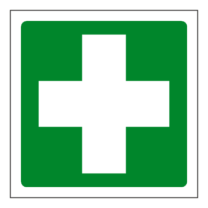

First Aid – Be prepared

***In preparation for your Emergency First Aid at Work course you should research the following 10 areas:***

1. Understand the role and responsibility of a First Aider.

2. Be able to assess an incident.

3. Be able to manage a casualty who is unresponsive and NOT breathing normally.

4. Be able to provide first aid to an unresponsive and breathing normally casualty.

5. Be able to manage a casualty who is in seizure.

6. Recognise and assist a casualty who is choking.

7. Manage a casualty with external bleeding.

8. Manage a casualty who is in shock.

9. Understand how to manage a casualty with a minor injury.

10. Understand how to manage a casualty with minor burns and scalds.

**This will give you the best possible chance to successfully achieving SCQF level 6,**

**Emergency First Aid at Work. However, you will be taught all of these things on the day**

**of training so that you fully understand them before you are assessed.**

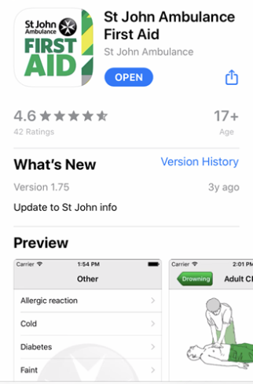

**You could also download and explore the St John’s Ambulance**

**First Aid App as part of your research.**